|  |  |
| --- | --- |
| OMA reveals '24/7 vertical city' proposal for southbank by beulah ...  Opening a Mexican restaurant in Melbourne | Description  A just arrived Mexican chef came to Melbourne with one shot to open a successful restaurant in the city, but where is the ideal location?  Ernesto Cangas Compean  *Applied Data Science Capstone* |

**Index**

Introduction………………………………………………………………………………………………….2

Data………………………………………………………………………………………………………………3

Methodology…………………………………………………………………………………………………5

Results…………………………………………………………………………………………………………13

Discussion……………………………………………………………………………………………………15

Conclusion…………………………………………………………………………………………………..15

**Introduction**

***Background***

The City of Melbourne is a local government area in Victoria, Australia, located in the central city area of Melbourne. Melbourne has 29 local government areas and the city of Melbourne is the one in the center of and which we are going to explore in this project. In 2018 the city had an area of 37 square kilometers and a population of 178,955 habitants.

Melbourne is an important financial center. With a highly diversified economy with particular strengths in finance, manufacturing, research, IT, education, logistics, transportation and tourism. In the 2018 Global Financial Centers Index, the city was ranked as having the 15th most competitive financial center in the world and is expected to rise five positions to be the 35th largest city economy in the world with a GDP of 273 billion USD at 2015-dollar prices.

The city has 14 suburbs with following habitants:

|  |  |
| --- | --- |
| Carlton | 18,535 |
| Carlton North | 6,300 |
| Docklands | 10,964 |
| East Melbourne | 4,964 |
| Flemington | 7,719 |
| Kensington | 10,812 |
| Melbourne CBD | 47,285 |
| North Melbourne | 14,940 |
| Port Melbourne | 16,175 |
| Parkville | 7,409 |
| Southbank | 18,709 |
| South Wharf | 106 |
| South Yarra | 25,147 |
| West Melbourne | 5,515 |

***Problem***

The matter that I’m going to address is if there is an ideal location to open a Mexican restaurant in the city of Melbourne.

***Stakeholders***

The business request came from a just arrived immigrant chef coming from Mexico. He has one shot to launch his restaurant successfully, so having a proper location is crucial.

**Data**

***Sources***

The information providers of this projects consist mainly of tree sources:

1. City of Melbourne ABS 2016 census basic community profile

* <https://www.abs.gov.au/AUSSTATS/abs@.nsf/DetailsPage/3218.02018-19?OpenDocument>

1. Python geocoder to get the coordinates of Melbourne suburbs

* <https://towardsdatascience.com/geocode-with-python-161ec1e62b89>

1. Foursquare API

* <https://es.foursquare.com/developers/apps>

***Description***

Firstly, the population data will be distributed between zones, which in this case will be the city preestablished suburbs, in order to see the different number of residents and explore this data for our advantage.

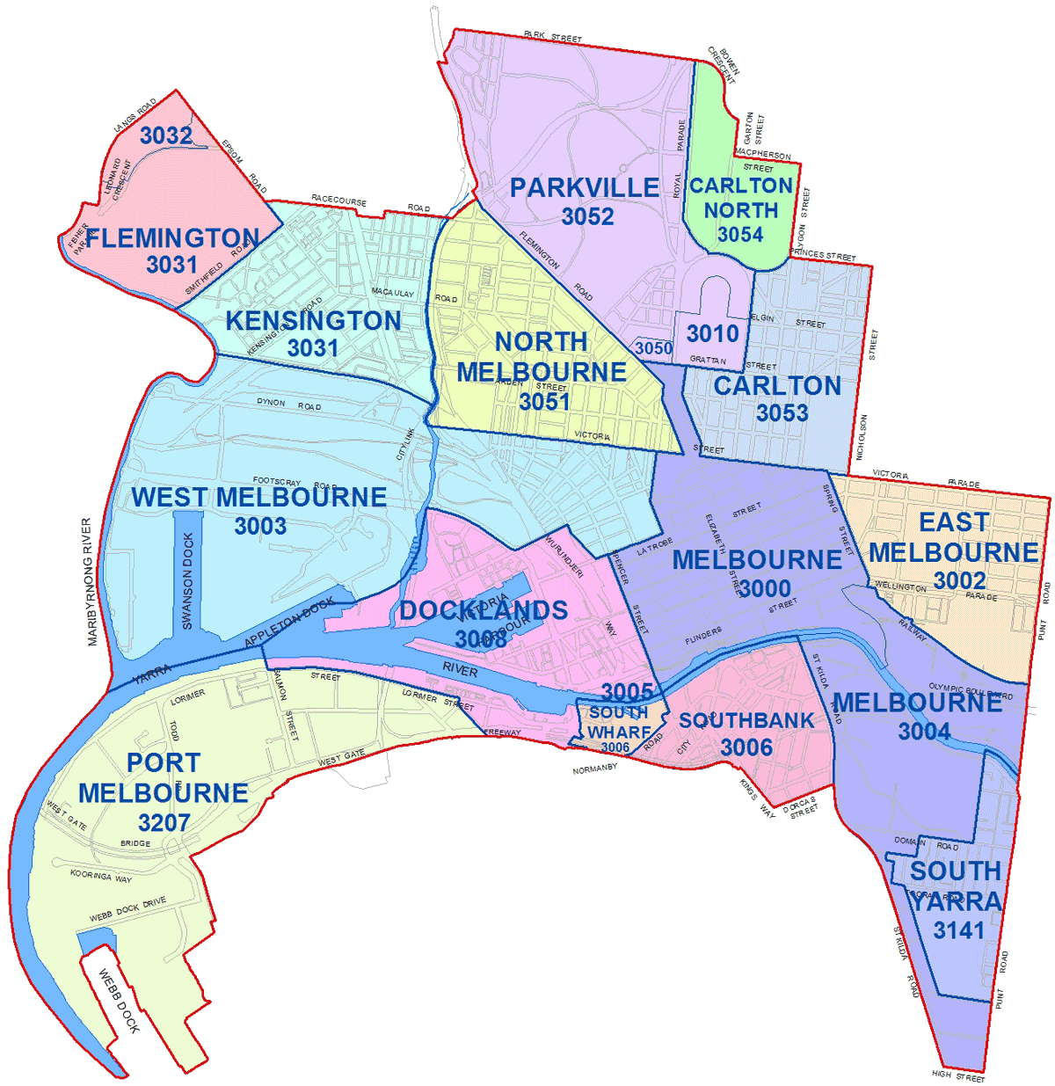

Secondly, the python geocoder will provide the coordinates of the neighborhoods to properly locate them in the city map with folium library.

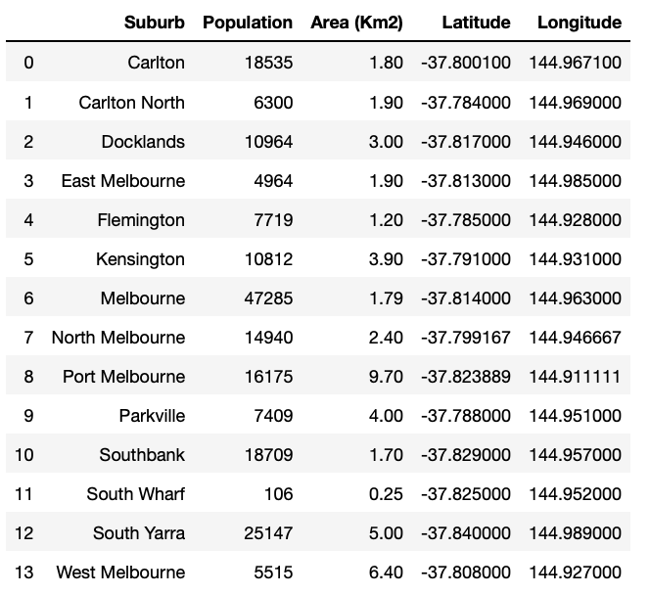

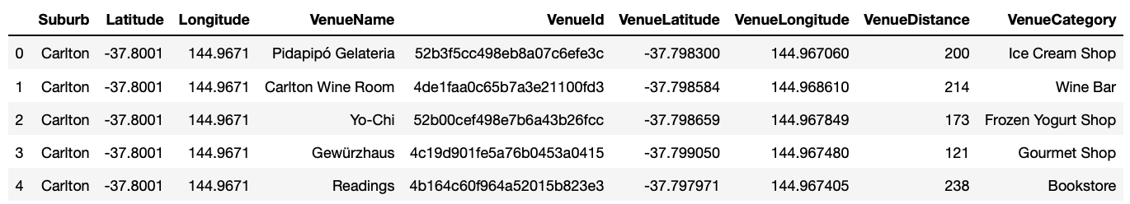Lastly, Foursquare API venues explore and method to obtain the venues of given suburbs of Melbourne.

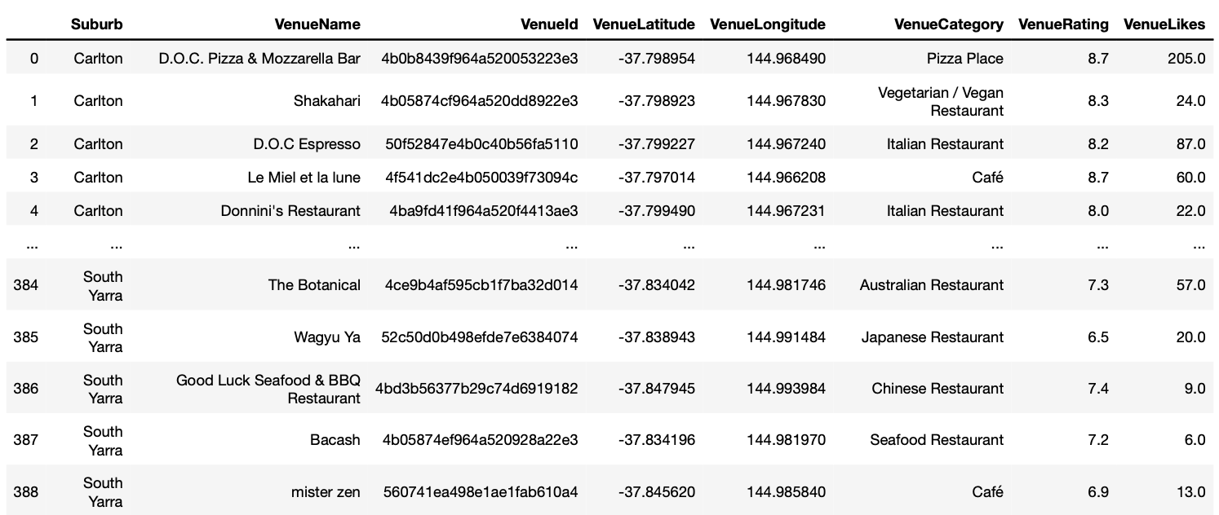Also, to get ranks and likes of restaurants by given venue id.

**Methodology**

***Data analysis***

Started with the population analysis by suburb.

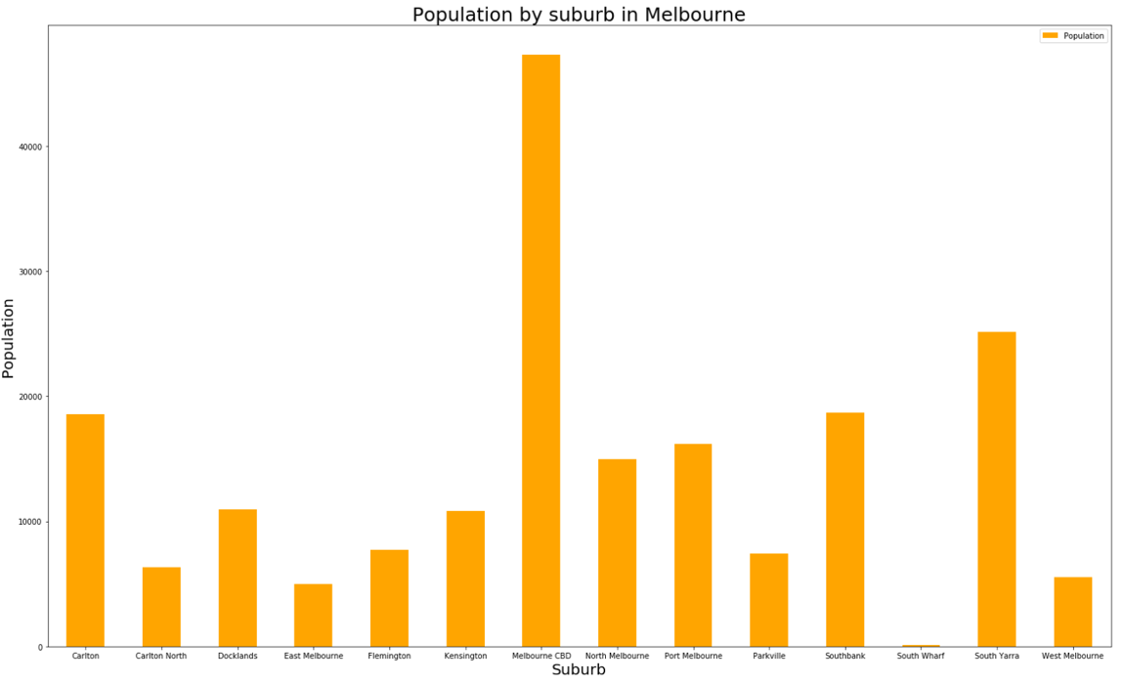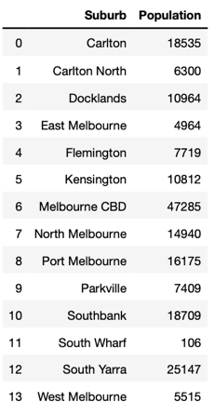

Moreover, a people/km2 scatter plot by suburb.

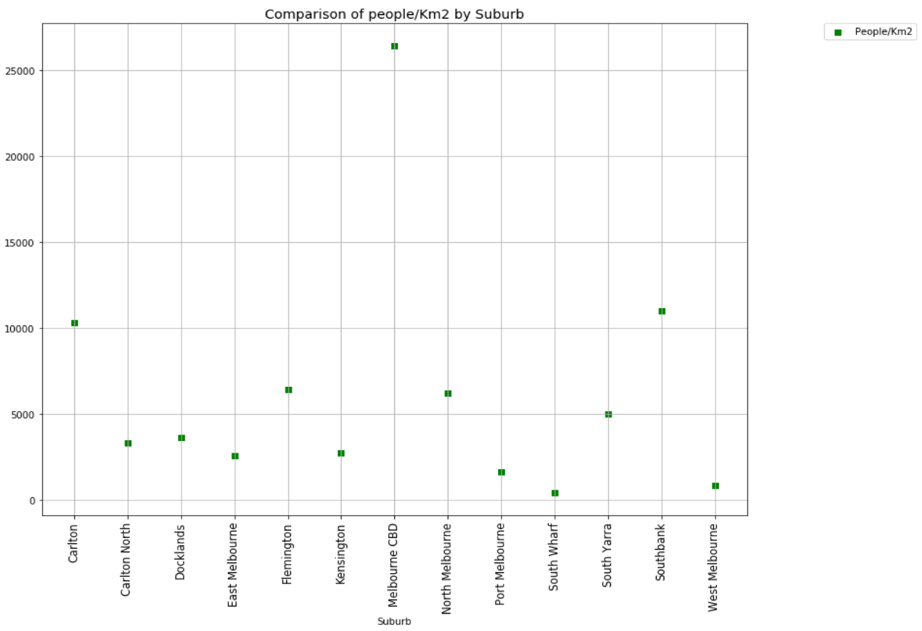

Then I located the suburbs in a Map, with their respective population.

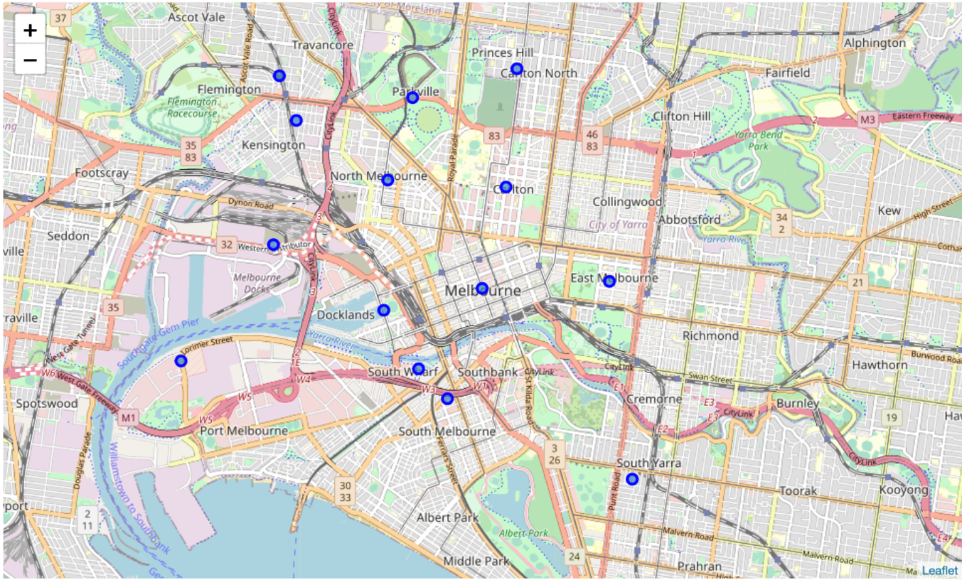

Afterwards, the top 10 restaurant types in Melbourne were obtained and illustrated with a waffle chart and a pie chart.

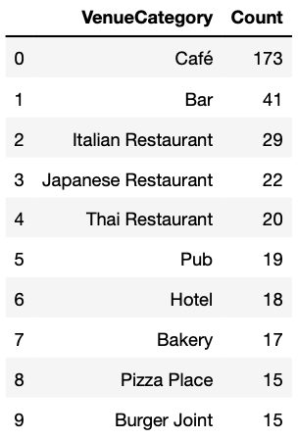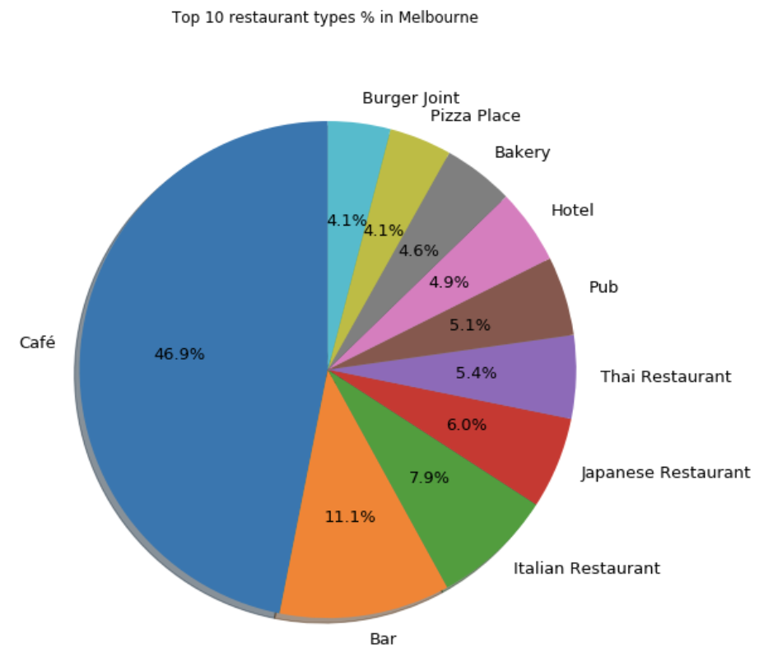

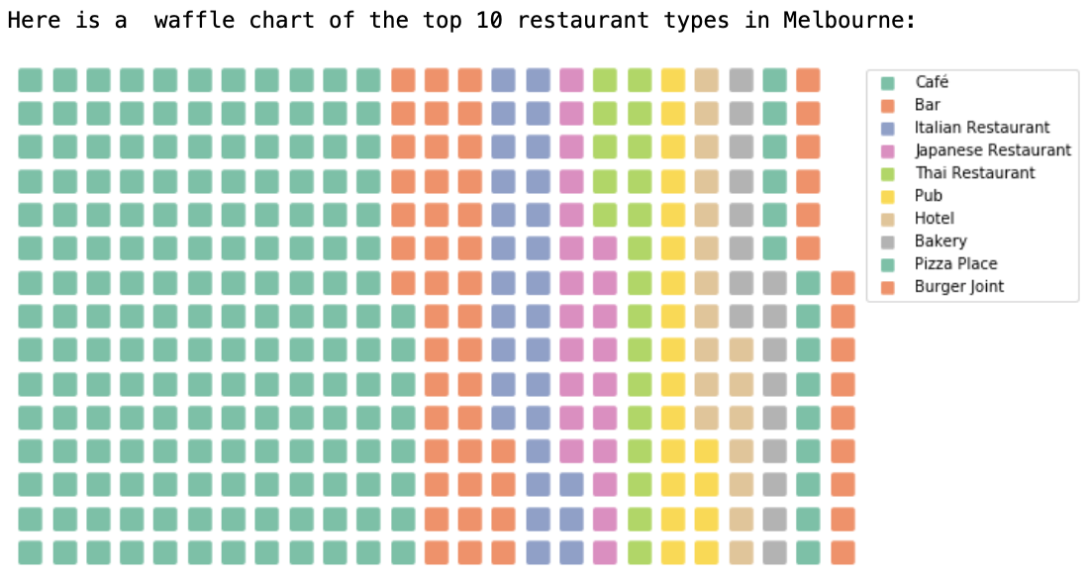

Next, I extracted the name of the Mexican Restaurants and coordinates to visualize them.

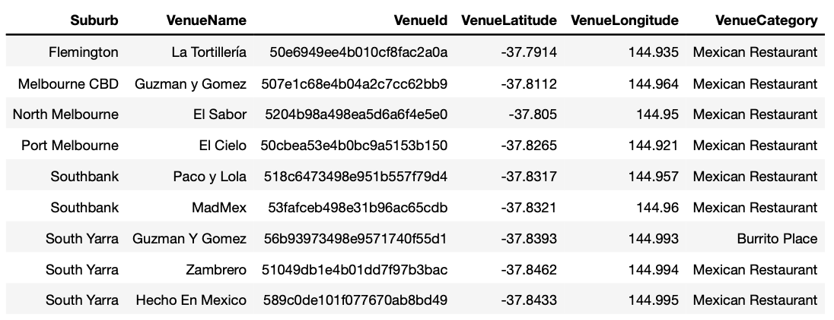

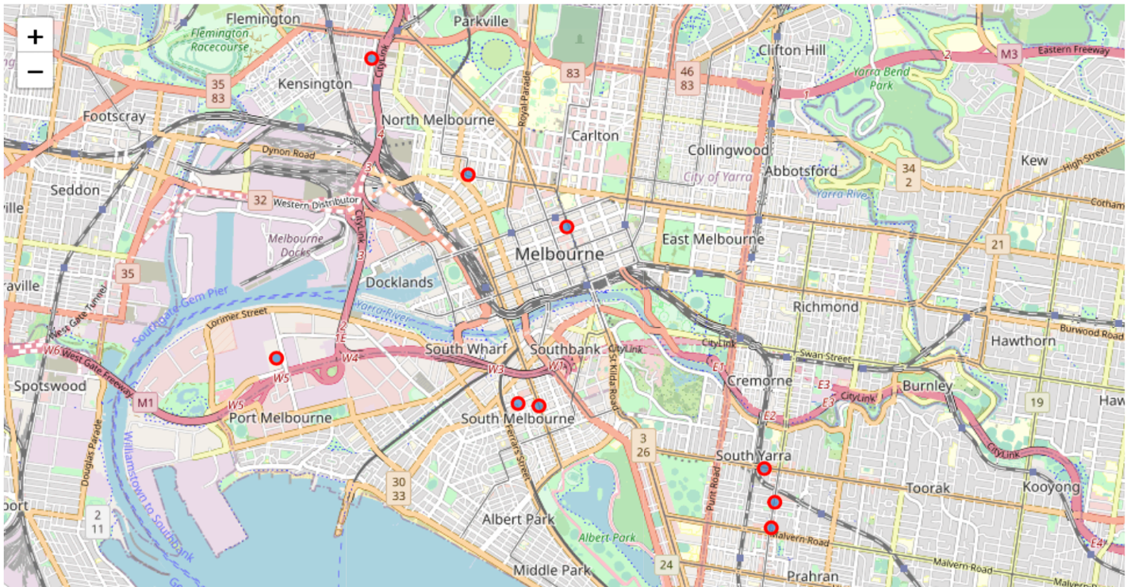

Then I analyzed the % of restaurants that were Mexican from the whole.

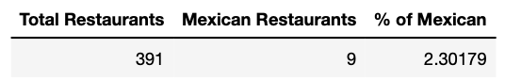

The extracted Mexican restaurants were grouped by suburbs.

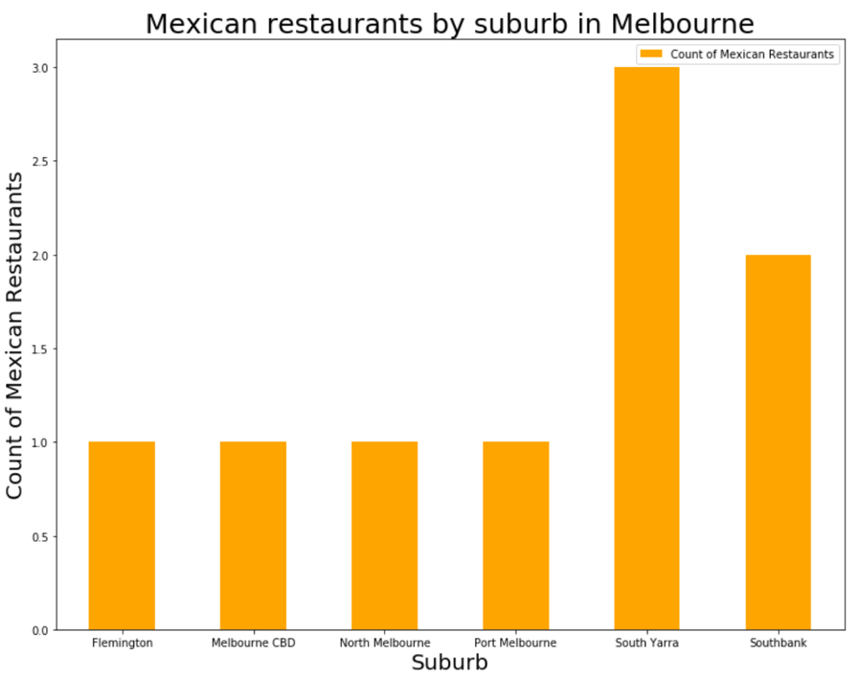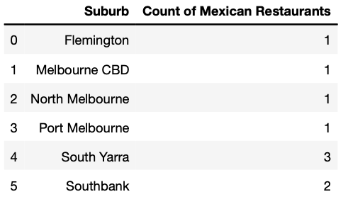

And illustrated it with a heat map.

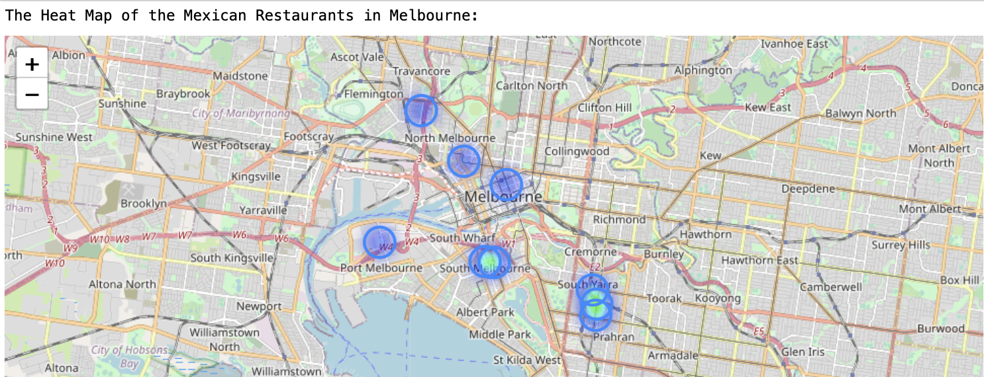

The same analysis was done, but for all types of restaurants per suburb.

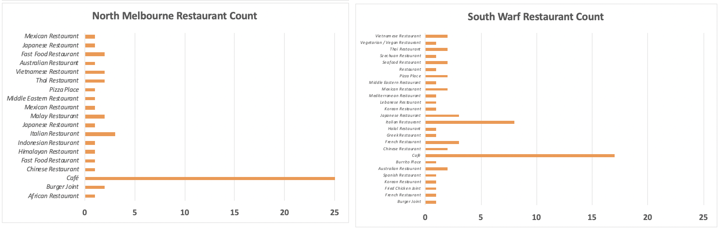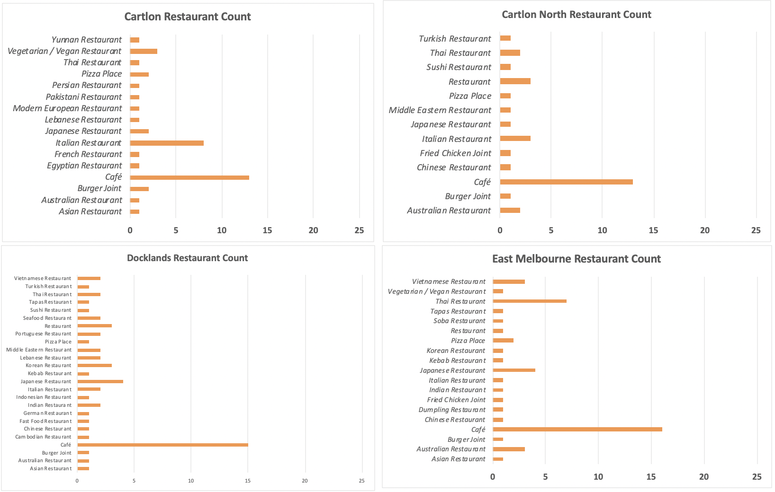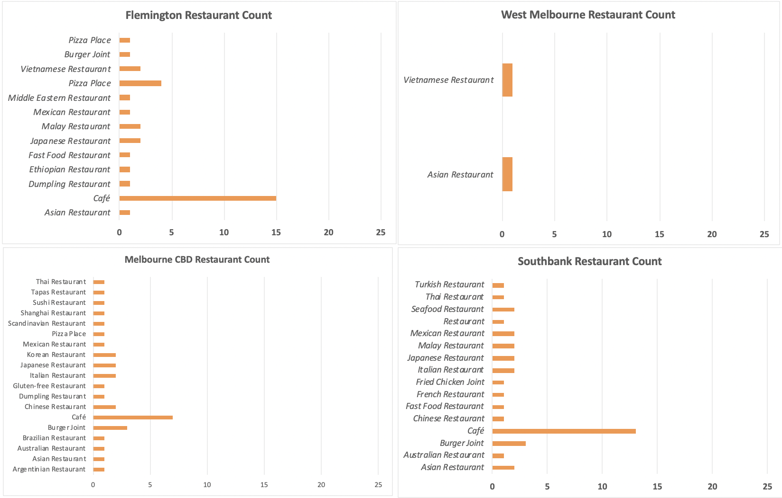Then I performed a statistical analysis to obtain the **MexicanRestaurants/Km2**, **AllRestaurants/Km2**, **MexicanRestaurants/100habitans**, **AllRestaurants/100habitants** by suburb.

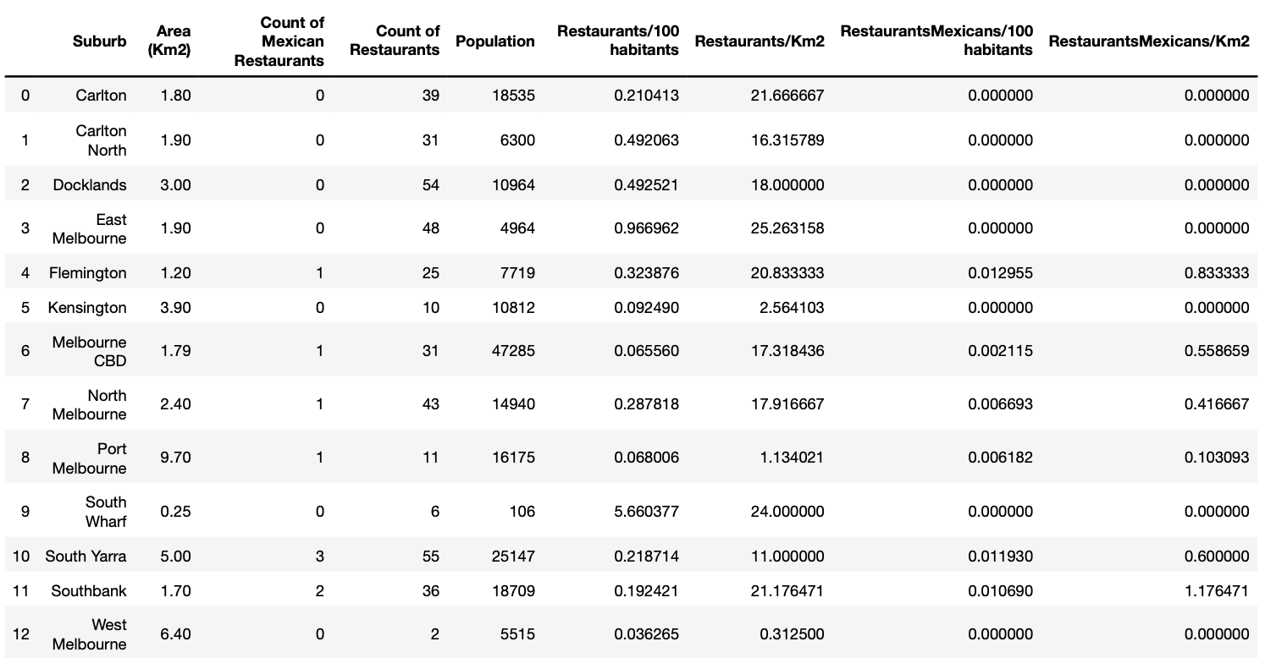

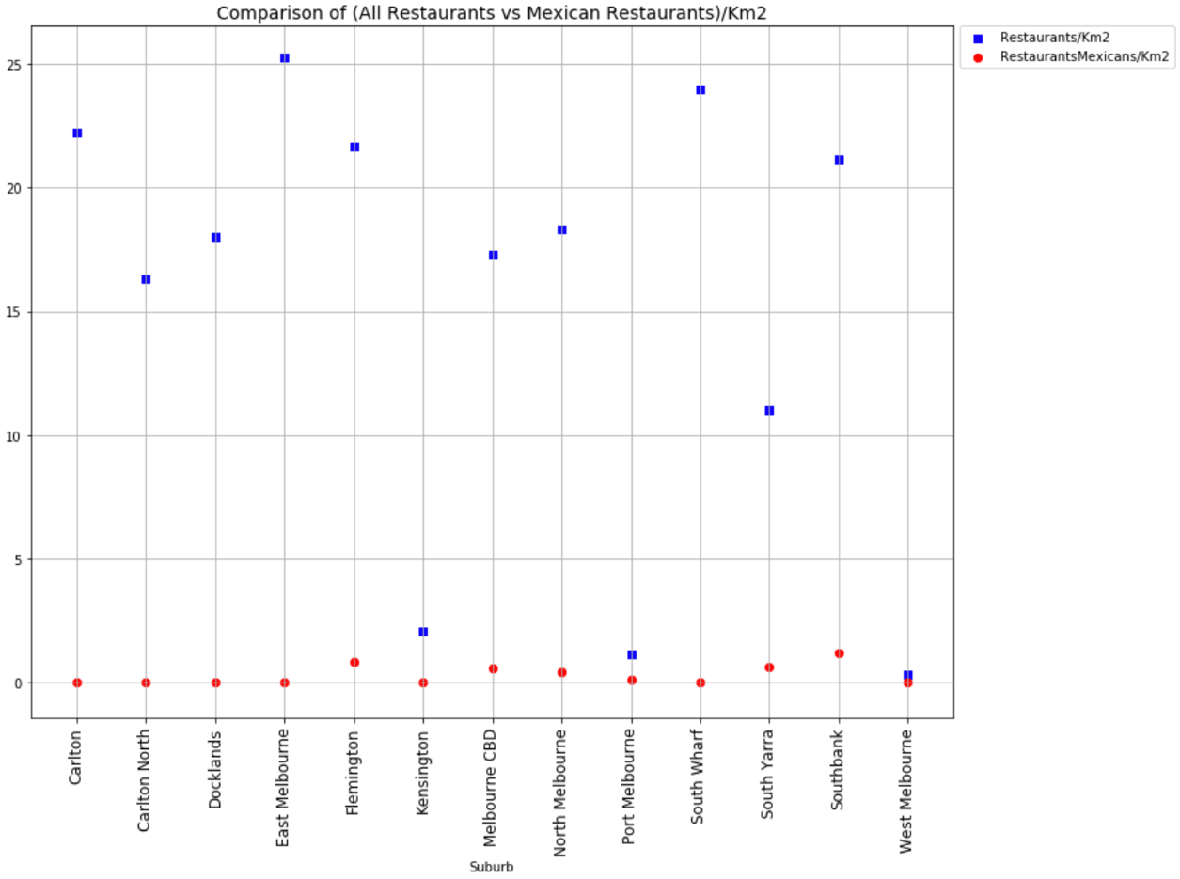The previous was compared by scatter plots and with the same units.

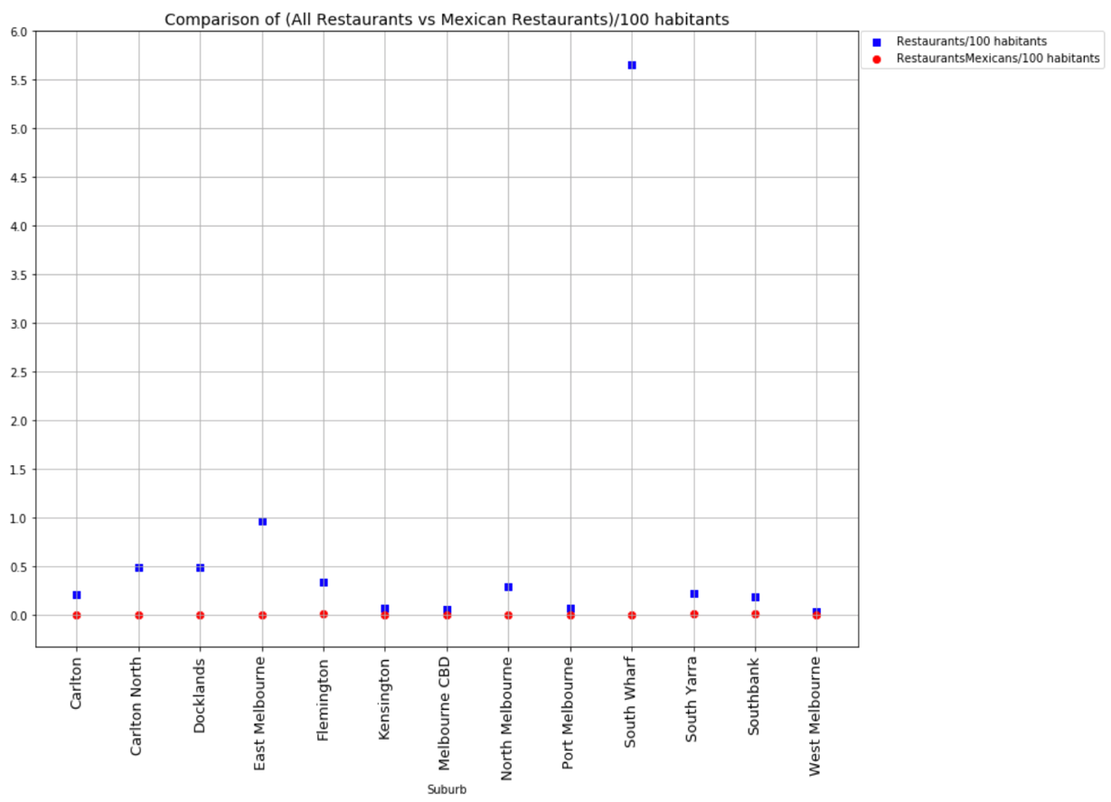

I continued with the average ratings and likes analysis for Mexican restaurants by suburb.

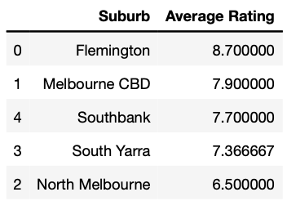

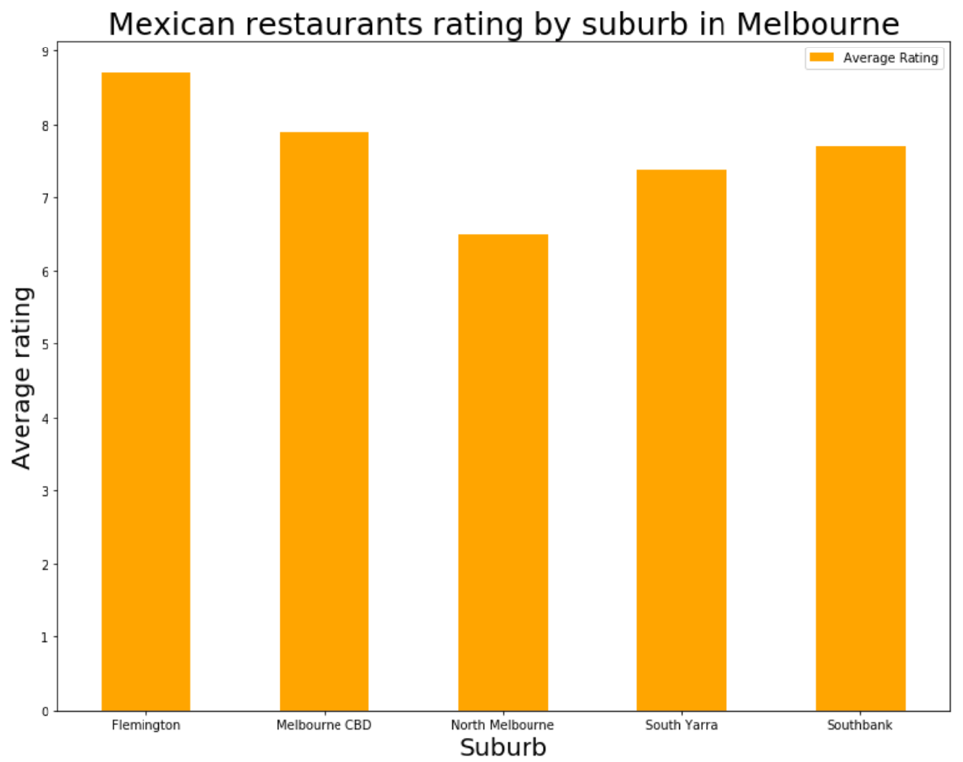

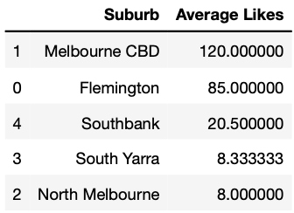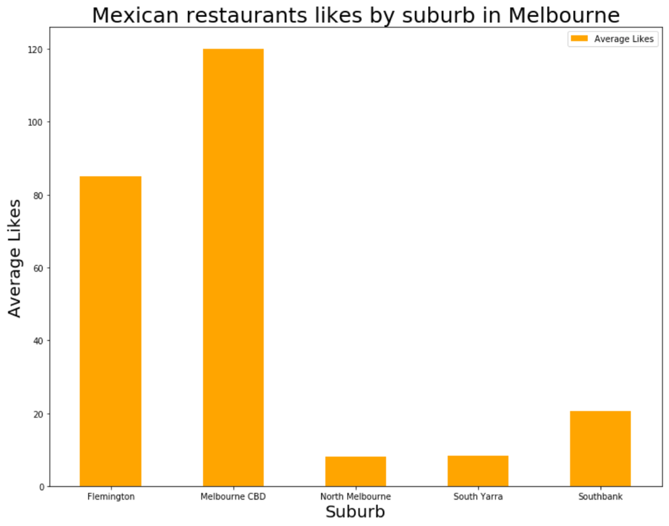

Lastly, both analyzes were plotted in a bubble map chart with a traffic light colors display. The average rating of Mexican restaurants by suburb.

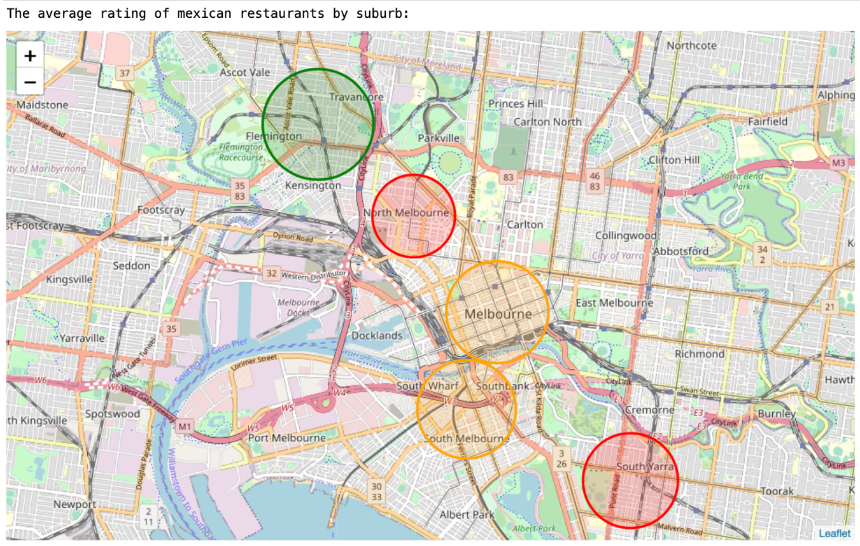

The average likes of Mexican restaurants by suburb.

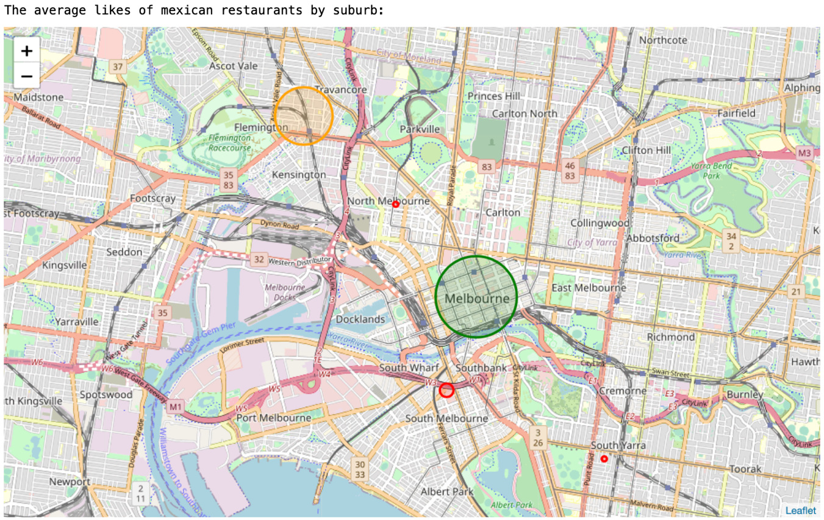

**Results**

***Population analysis***

-Melbourne CBD has the largest population with 18,535 people

-South Wharf has the lowest population with 106 people

-Melbourne CBD has the largest population/Km2 with 26,416.2 people/Km2

-South Wharf has the lowest population/Km2 with 424 people/Km2

***Top restaurant categories analysis***

-Cafés are the most popular category in Melbourne

-Italian restaurants are the second most popular category in Melbourne

-Japanese restaurants are the third most popular category in Melbourne

***Mexican restaurant analysis***

-2.3% of all restaurants are Mexican

*Average rating by suburb*

-Flemington has the best average rating for Mexican restaurants is with 8.7 rating

*Likes by suburb*

-Melbourne CBD has the most likes for Mexican restaurants is with 120 likes

*Restaurant amount/Km2 by suburb*

-Southbank has the most MexicanRestaurants/Km2 with 1.1764 Restaurants/Km2

-Port Melbourne has the least MexicanRestaurants/Km2 with .103 Restaurants/Km2 (other than the ones with 0 Mexican Restaurants)

*Restaurant amount by suburb*

-South Yarra has the most Mexican restaurants with 3 restaurants

-Suburbs with 1 Mexican restaurant:

Flemington

Melbourne CBD

North Melbourne

Port Melbourne

-Suburbs with 0 Mexican restaurants are:

Carlton

Carlton North

Docklands

East Melbourne

Kensington

Parkville

South Wharf

West Melbourne

*Restaurant amount/100 habitants by suburb*

-Flemington has the most MexicanRestaurants/100 habitants with 0.0129 restaurants/100habitants

-Melbourne CBD has the least MexicanRestaurants/100 habitants with 0.0021

restaurants/100habitants (besides the ones with 0 restaurants)

***All restaurants analysis***

-There are 392 restaurants in Melbourne

*Restaurant amount/Km2 by suburb*

-East Melbourne has the most Restaurants/Km2 with 25.26 Restaurants/Km2

-West Melbourne has the least Restaurants/Km2 with .3125 Restaurants/Km2

*Restaurant amount by suburb*

-South Yarra has the most restaurants with 55 restaurants

-West Melbourne has the least restaurants 0 restaurants

*Restaurant amount/100 habitants by suburb*

-South Wharf has the most Restaurants/100 habitants with 5.66 restaurants/100habitants

-West Melbourne has the least Restaurants/100 habitants with 0.0362 restaurants/100habitants

**Discussion**

My investigation points out some opportunity locations for Mexican restaurants. Nonetheless, it brings a dilemma between opening one in Flemington due to the high concentration of average likes (85) and average rating (8.7) for this restaurant category, with a low number of Restaurants/100 habitants (.32), also with a high number of venues/Km2 (20.8) and just one Mexican Restaurant in the area.

On the other hand, East Melbourne is becoming more popular with time. It has a high concentration of Restaurants/100 inhabitants (.96) and the highest number of venues/Km2 (25.2). This suburb has 0 Mexican Restaurants. However, it is just next to Melbourne CBD, which has the second-highest rating for Mexican Venues, best like average, and it’s just next to Fitzroy. The last Melbourne demographic analysis, made in 2011, shows that Fitzroy is the city with the highest concentration of Spanish/Mexican population.

**Conclusion**

My final recommendation would be to open a Mexican restaurant in East Melbourne, since it is a suburb that is trending in terms of food places. Furthermore, it is near to Fitzroy and to Melbourne CBD (Central Business District), there is no actual Mexican food competition right now and being the first in something always pays off.